

Learning Academy | D-SDL | May 31, 2016

Developing Self-Directed Learning
  - Students’ resource guide

What is Self-Directed Learning?
?


?

What is Self-Directed Learning?

Self-Directed Learning is about diagnosing your learning needs, (where am I now?) identifying your learning goals (where am I going?), implementing learning strategies (how do I get there? & am I there yet?) and evaluating learning outcomes (how well did you learnt).





How well did I learn?
Am I there yet?
How do I get there?
Where am I now?
Where am I going to?

Self-Directed Learning

Like any other study skill, you can learn to acquire Self-Directed Learning skills.
There is a 4-step learning process to help you develop Self-Directed Learning skills.


4-step process
PPMR

4-step process to develop self-directed learning skills
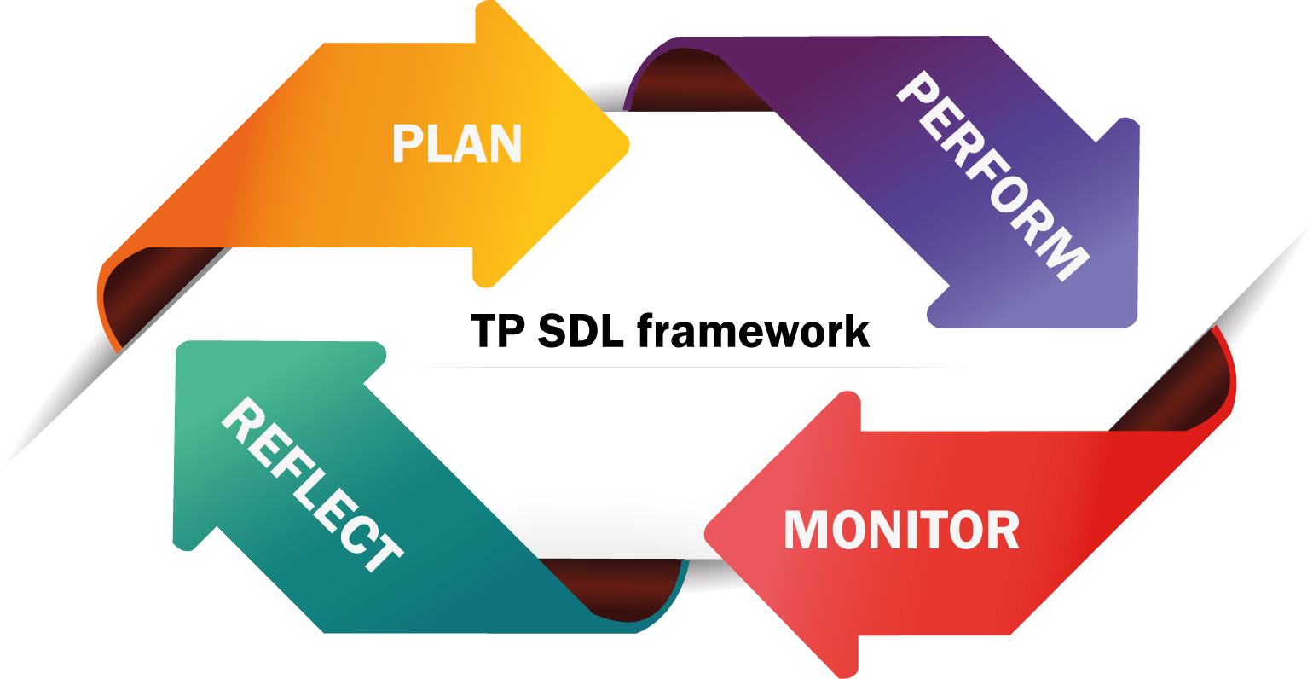

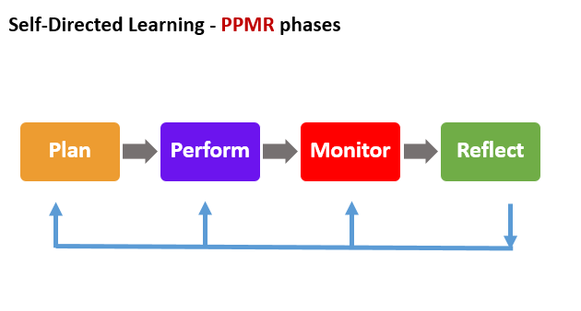

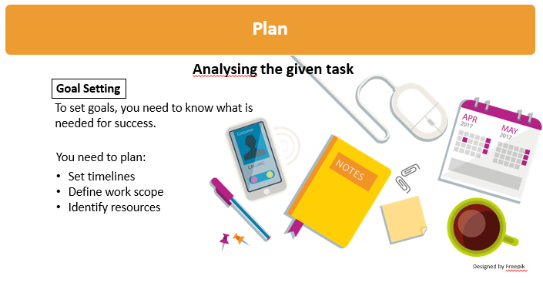

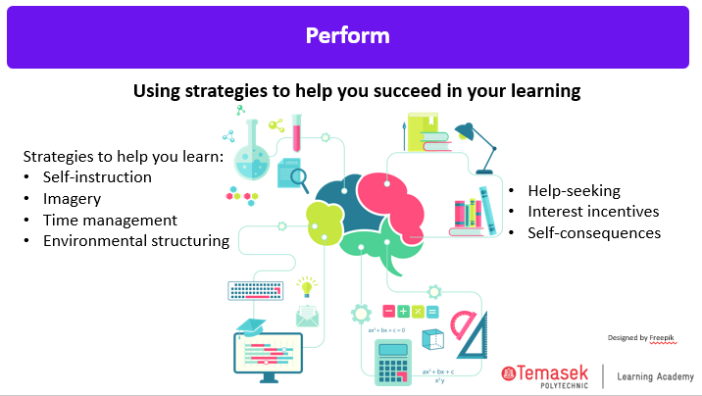

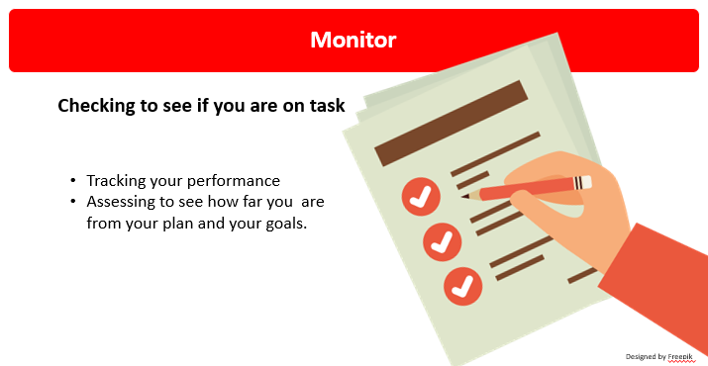

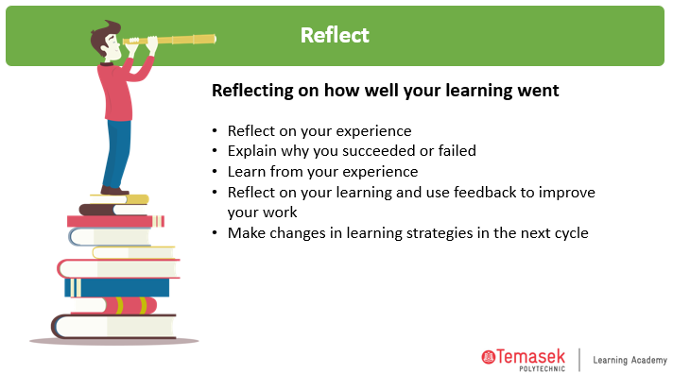

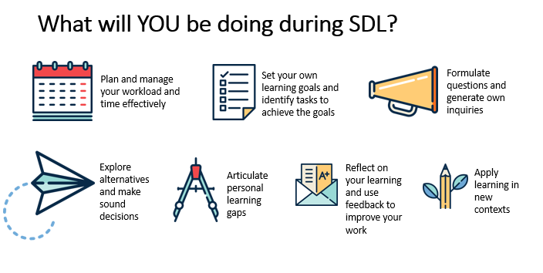

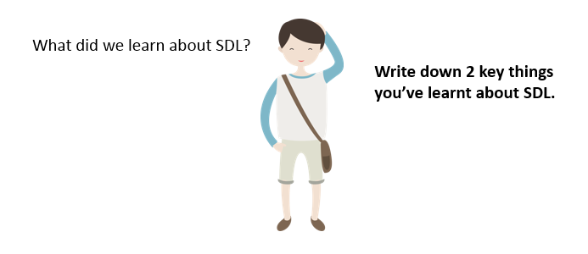

Template 1
Name: | Date:
Where Am I Going?
My Goal:

Where Am I Now?
What I can do: | What I need to work on:
How Will I Close the Gap?
- With help from:

- Using these resources:

- Actions I will take:

What: | When:

PERFORM

Template 2
Name: | Date:
Strategies that I am using

MONITOR

Template 3
Name: | Date:
Learning Target:
Right now, I…

Current Status?
Evidence of Current Status:
Plan:
Evidence of Achieving My Goal:
REFLECT

Template 4
Name: | Date:
Write a reflection on your learning through this project:
Describe:
- Write about how you planned for the completion of your project
- Describe how you’ve been monitoring your own progress while doing the project

Examine:
Examine how you went about doing the project and how you closed the gap in your learning.

Articulated Learning:
Write about some strategies or skills you have learnt through this project.
Given another project, might there be anything you would do differently from what you have done?

